**Overview:**

There are a total of four questions on this assignment. Please complete and submit your answers via email at your earliest convenience. The following file formats are acceptable: ipynb, word, excel, powerpoint, .py, .csv, .me, .sql file.

**Questions 1 (SQL):**

Given two tables. What is the SQL syntax to get IDs from Table 1 that are not in Table 2? (t1id is the primary key for Table 1, t2id is matching primary key from table 2)

Tables 1 Table 2

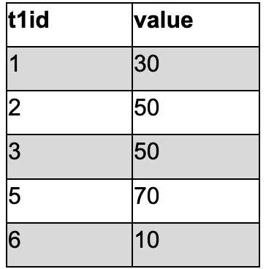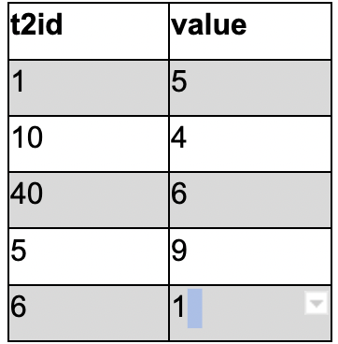

**Question 2 (SQL):**

Given a table that has multiple rows per id; what is the SQL syntax to get the IDs and values of the rows with the latest modifiedDTS?

| **t3id** | **modifiedDTS** | **value** |
| --- | --- | --- |
| 1 | 1/1/2020 | 1 |
| 1 | 1/2/2020 | 2 |
| 1 | 1/3/2020 | 3 |
| 2 | 2/1/2020 | 4 |
| 2 | 4/1/2020 | 7 |
| 3 | 5/1/2020 | 4 |
| 3 | 6/10/2020 | 7 |
| 3 | 2/28/2020 | 9 |
| 3 | 11/11/2022 | 22 |
| 4 | 1/1/2022 | 3 |
| 5 | 7/4/2020 | 4 |

**Question 3 (Python):**

Given Table 4; what is the python syntax to transform a (input) dataframe to an (output) dataframe with **createdDTS** and **t3id** as the index, columns from **metric**, and column values from **value**?

Input Output:

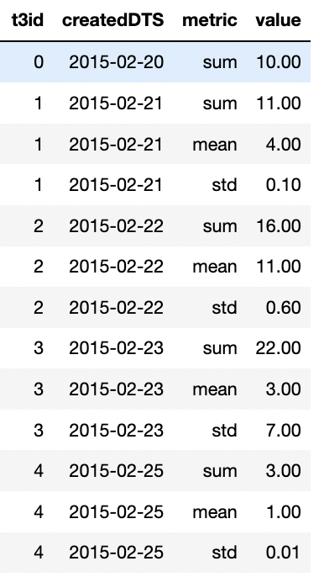 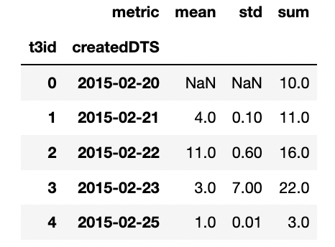

**Question 4 (Open Ended):**

Augur is a decentralized prediction market platform built on the Ethereum blockchain. We’d like to scrape their blockchain data to gain insights into wallet addresses that have Augur.

They have two contract addresses (augur_contract, augur_contract_v1 in code snippet below). REP ICO was in 2015 and launched in 2018. REPV2 launched in 2020.

Etherscan is a block explorer and analytics platform that allows access to details on any Ethereum blockchain. They have an API that can be reached to extract information ([docs](https://docs.etherscan.io/)). The below code snippet is an example of how to get a response from the below endpoint in Python.

Objective:

Write a script that extracts Augur’s historical token transfer events. Get a large enough sample size to use the results for analysis.

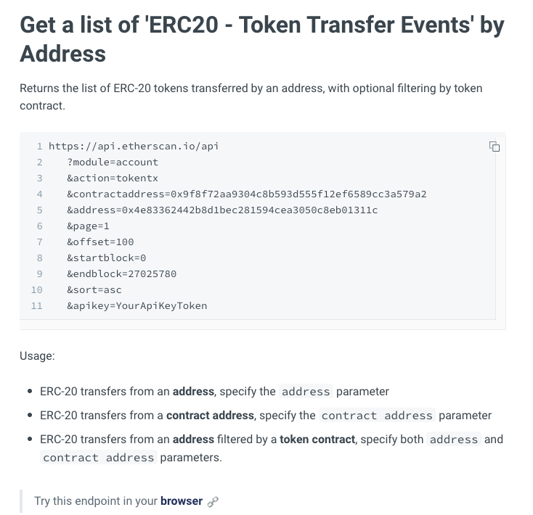

import pandas as pd

import requests

try:

from etherscan import Etherscan

except:

!pip install etherscan-python

from etherscan import Etherscan

eth_key = "7U3C64WMQWE9TVUHWG8FMRXIGGAB1NR5AT"

eth = Etherscan(eth_key) # key in quotation marks

# augur contract addresses

augur_contract = "0x221657776846890989a759BA2973e427DfF5C9bB"

augur_contract_v1 = "0x1985365e9f78359a9B6AD760e32412f4a445E862"

# example of getting a response from etherscan ipo endpoint to get ERC20 - Token Transfer Events’ by address (&module=account&action=tokentx)

def fetchEthERC20TransfersFromWalletOrContract(wallet='',

page_num=1,

contract=augur_contract):

response = requests.get(f"https://api.etherscan.io/api?module=account&action=tokentx&contractaddress={contract}&page={page_num}&offset=10000&startblock=0&endblock=14731209&sort=desc&apikey={eth_key}")

response_code = response.status_code

if response_code == 200:

return response.json()

else:

print(f"Check Response Code: {response_code}")